

**int_talkable**

Salesforce Commerce Cloud  
Integration Guide

*Version 22.1.0*

Table of Contents

1. Summary 3

2. Component Overview 4

2.1. Functional Overview 4

2.2. Use Cases 4

2.2.1. Invite Campaign 4

2.2.2. Reward Gleam Campaign 5

2.3. Limitations, Constraints 5

2.4. Compatibility 5

2.5. Privacy, Payment 5

2.6. Integration Components 6

3. Implementation Guide 7

3.1. Setup 7

3.1.1. Import Cartridge 7

3.1.2. Business Manager settings 8

3.2. Configuration 10

3.3. Custom Code 12

3.3.1. SG customizations 12

3.3.2. SFRA customizations 14

3.4. External Interfaces 17

3.5. Firewall Requirements 17

4. Testing 17

4.1. Unit Tests 17

5. Operations, Maintenance 17

5.1. Data Storage 17

5.2. Availability 17

5.3. Failover/Recovery Process 17

5.4. Support 17

6. User Guide 18

6.1. Roles, Responsibilities 18

6.2. Business Manager 18

6.3. Storefront Functionality 18

6.3.1. Storefront Invite Pop-Up 18

6.3.2. Storefront Dashboard 21

7. Known Issues 22

8. Release History 22

# Summary

Talkable is changing the way e-commerce companies acquire and retain customers, through one of the most powerful marketing tools—referrals. Refer-a-friend programs allow businesses to acquire new customers through the endorsement of their friends and family, shared via email, SMS, and other social channels.

This document describes how to implement the Talkable cartridge into the Salesforce Commerce Cloud site. The Talkable cartridge is a self-contained cartridge that can easily integrate into any Salesforce Commerce Cloud project. The cartridge can be configured in the Business Manager and contains all elements necessary to perform successful best practice implementation of Talkable.

After the cartridge is deployed, configured and integrated with the storefront templates, the customer will have the full power of Talkable marketing programs applied to their site.

In order to use the Talkable integration, you will need to contact Talkable before installing. Please reach out to [sales@talkable.com](mailto:sales@talkable.com) for details.

# Component Overview

## Functional Overview

Talkable enables your Salesforce Commerce Cloud store to attract new customers by offering them special deals in exchange for sharing with their friends.

This cartridge provides links for Advocates to share on Facebook, Twitter, and Email and encourages them to bring in new customers for you.

Using Talkable, you help your customers drive more referral sales per dollar than traditional marketing and advertising.

## Use Cases

Talkable can be used to create referral marketing campaigns of different types.

### Invite Campaign

Invite campaigns are powerful and versatile. They increase the number of new customers by giving anyone an opportunity to invite their Friends from various high traffic locations on the website as well as outside the website. You can set up multiple Invite campaigns to run simultaneously.

 *Invite Campaign.*

### Reward Gleam Campaign

The Reward Gleam improves the on-site conversion rate by assisting Friends and Advocates in using their coupons to purchase. When the Friend or Advocate gets a reward and goes to your website, the Reward Gleam captures the coupon code and displays it in a highlight bar at the bottom of the page. This type of campaign focuses on both Friends and Advocates and can be the perfect addition to any of your other campaigns.

 *Reward Gleam Campaign.*

## Limitations, Constraints

The installation of the Talkable cartridge alone does not grant usage of Talkable. Every store must register for a Talkable plan to gain access to cartridge functionality. Please reach out to [sales@talkable.com](mailto:sales@talkable.com) for details.

## Compatibility

This cartridge is designed for Salesforce Commerce Cloud API 21.7.

Cartridge is compatible with SFRA storefront versions 5.3.0 - 6.0.0.

Cartridge is compatible with SiteGenesis version 105.1.0.

Older versions may work with small changes but were not tested.

## Privacy, Payment

Using Talkable binds you to the following [terms of service](https://www.talkable.com/tos).

Please read our [privacy policy](https://www.talkable.com/privacy) to understand how Talkable protects the information it collects.

Payment details are discussed on a per client basis and can be determined by reaching out to [sales@talkable.com](mailto:sales@talkable.com)

## Integration Components

Talkable consists of 3 cartridges – *int_talkable* integration cartridge, *talkable_sfra_custom*, *talkable_sg_custom* that implements the functionality for storefront. The *int_talkable* cartridge has the following components:

* **Cartridge name**
  + *int_talkable*
* **Controllers**
  + *Talkable.js*
* **Scripts**
  + *talkable/libTalkable.js*
* **Templates**
  + *talkable/dashboard.isml*
  + *talkable/head.isml*
  + *talkable/postCheckout.isml*
  + *talkable/postCheckoutSummary.isml*
  + *talkable/standalone.isml*
* **Resources**
  + *int_talkable.properties*

The *talkable_sfra_custom* cartridge contains some customization only needed by SFRA storefront:

* **Controllers**
  + Order.js
* **Templates**
  + account/dashboardCard.isml
  + account/dashboardProfileCards.isml
  + account/dashboardSfra.isml
  + checkout/confirmation/confirmation.isml
  + components/header/pageHeader.isml
  + components/header/pageHeaderNomenu.isml
  + talkable/standaloneSfra.isml
* **Resources**
  + custom.properties

The *talkable_sg_custom* cartridge contains some customization only needed by SiteGenesis storefront:

* **Templates**
  + checkout/pt_orderconfirmation.isml
  + components/header/htmlhead.isml

# Implementation Guide

Prerequisites

Before performing the steps in this document, ensure that you and your organization have satisfied the following criteria:

* You have reached out to Talkable and have obtained a Talkable Site ID to properly configure the Talkable cartridge. Talkable will create the required setup for the different campaigns (required by you) from Talkable’s client admin. Talkable will provide you the login credentials for client admin, where you can see and manage the different settings related to the campaigns activated for you.
* You have downloaded and unzipped the Talkable cartridge ZIP file from Salesforce Commerce Cloud Marketplace or your Talkable Technical Consultant. The cartridge ZIP file contains the Talkable cartridge package, which resides in the folder int_talkable, as well as the file SitePreferences-Talkable.xml, which contains Talkable custom site preferences.

## Setup

### Import Cartridge

To start using Talkable, import the *int_talkable* cartridge into Eclipse and upload them. If the storefront is of type SFRA also add the *talkable_sfra_custom* cartridge or If the storefront is of type SiteGenesis add the *talkable_sg_custom*, this cartridge must precede (come before) both the storefront and *int_talkable* as it overrides files from both (if you already have a storefront customization cartridge you can copy the functionality/file to the storefront customization cartridge).

1. Import the Talkable cartridge to a workspace in Salesforce UX Studio.

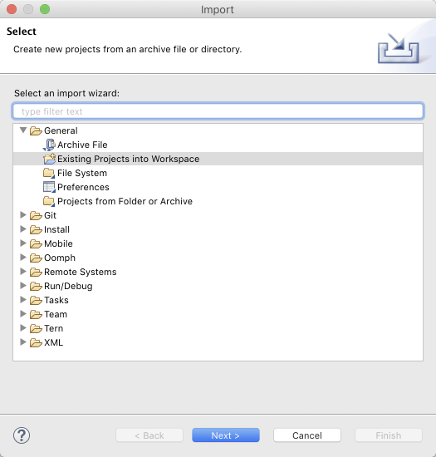

1. Attach the Talkable cartridge to the Digital Server Connection.

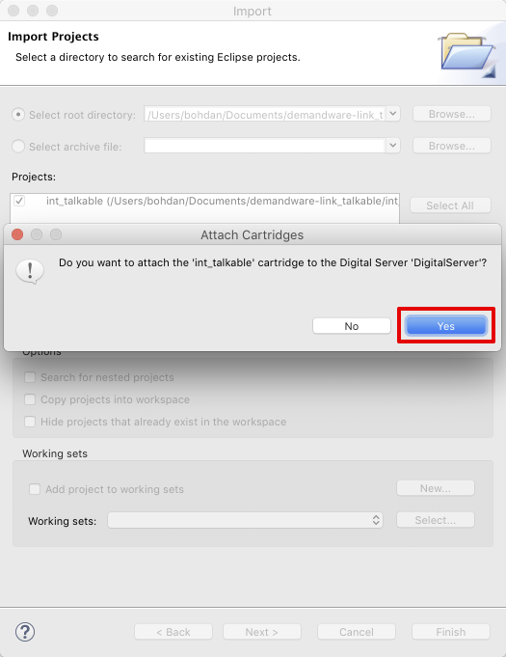

1. Wait until Studio completes workspace built and uploading of source codes to a sandbox.

### Business Manager settings

Go to Business Manager → Administration → Sites → Manage Sites. Select correct site, then select Settings tab. If the storefront is SFRA based the **int_talkable** needs to precede the SFRA base cartridge in the path and the **talkable_sfra_custom** needs to precede the **int_talkable** cartridge. Ex:

**talkable_sfra_custom:int_talkable:app_storefront_base**

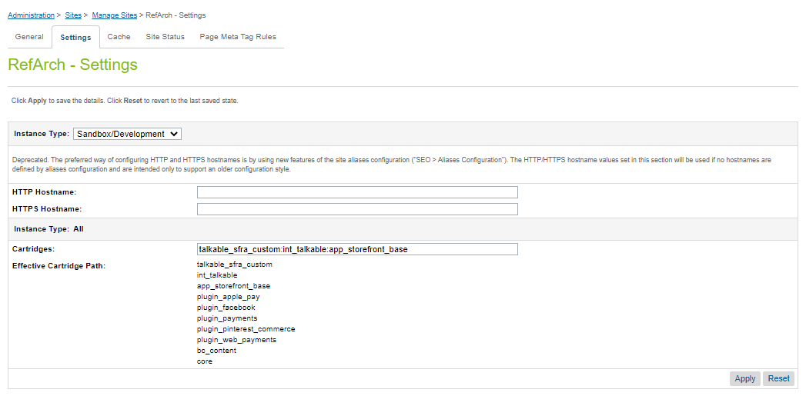

**If the storefront is SG** based the **int_talkable** needs to precede the SG base cartridge in the path and the **talkable_sg_custom** needs to precede the **int_ talkable** cartridge. Ex: **talkable_sg_custom:int_talkable:app_storefront_controllers:app_storefront_core**

1. Open the folder where you extracted the Talkable cartridge ZIP file, and find SitePreferences-Talkable.xml in folder metadata.
2. Go to Business Manager → Administration → Site Development → Import & Export. Click Upload button and select SitePreferences-Talkable.xml.

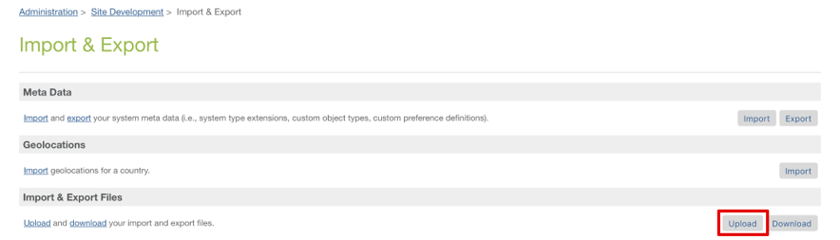

1. Click Import button and select SitePreferences-Talkable.xml.

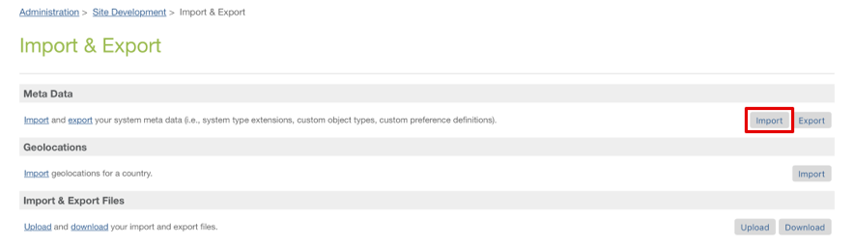

1. Go to Merchant Tools → Site Preferences → Custom Preferences. Verify that Site Preferences group was created with ID – *talkable* and name – *Talkable*.

## Configuration

This section describes configuration of the sandbox.

1. Go to Merchant Tools → Site Preferences → Custom Preferences → Talkable.

* Add site preference attribute – Talkable Site ID with provided Site ID from Talkable.
* Enable attribute – Post Purchase Campaign.
* Enable attribute – Invite Campaign.
* Enable attribute – Advocate Dashboard Campaign.
* Enable attribute – Floating Widget Popup Campaign.
* Enable attribute – Talkable Enabled.

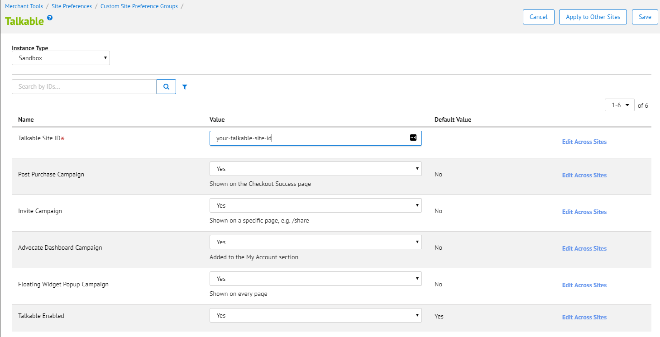

1. Go to Merchant Tools → SEO → URL Rules, then select Pipeline URLs tab.

Add the following rules:

**For SiteGenesis Storefronts:**

* *share* resolves to *Talkable-Standalone*
* *referral-dashboard* resolves to *Talkable-Dashboard*

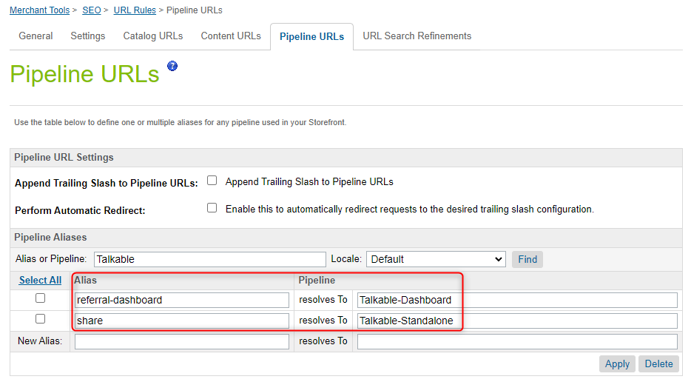

**For SFRA Storefronts:**

* *share* resolves to *Talkable-StandaloneSfra*
* *referral-dashboard* resolves to *Talkable-DashboardSfra*

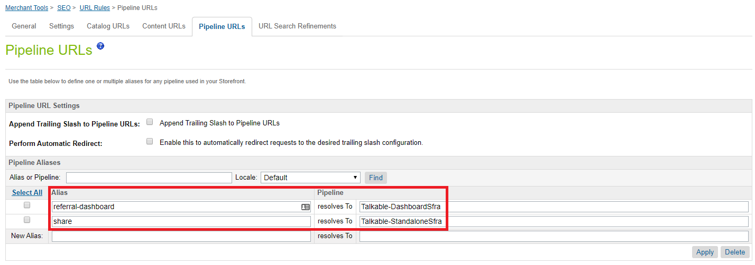

1. For the Advocate Dashboard Campaign to be shown in the My Account section, a small change required for ***SiteGenesis storefronts*** in the *account-nav-registered* content asset.

* Navigate to Merchant Tools → Content → Content Assets.
* Search for the *account-nav-registered* content asset.
* Lock the content asset in order to be able to edit it.
* Go to the body attribute and add the following line to the list of My Account section (please also check the screenshot below):

<li><a title="Referral Dashboard"

href="$httpsUrl(Talkable-Dashboard)$">Referral Dashboard</a></li>

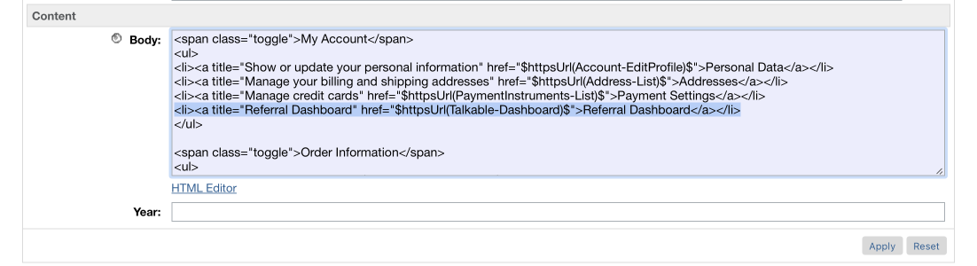

## Custom Code

This section describes changes that should be made to a merchant storefront cartridge.

The Talkable Integration for Salesforce Commerce Cloud requires some

customizations of the storefront cartridge. In addition to the steps required for customization described below we also provide two example cartridges with the customization already applied *talkable_sfra_custom* (for SFRA) and *talkable_sg_custom* (for SiteGenesis) that can be used as overlays or examples depending on your existing storefront customizations.

### SG customizations

1. Copy “templates/default/components/header/htmlhead.isml” file from

app_storefront_core to your storefront customization cartridge following the same path and paste below code at the end of the file:

<isinclude url=*"${URLUtils.url('Talkable-Head')}"*/>

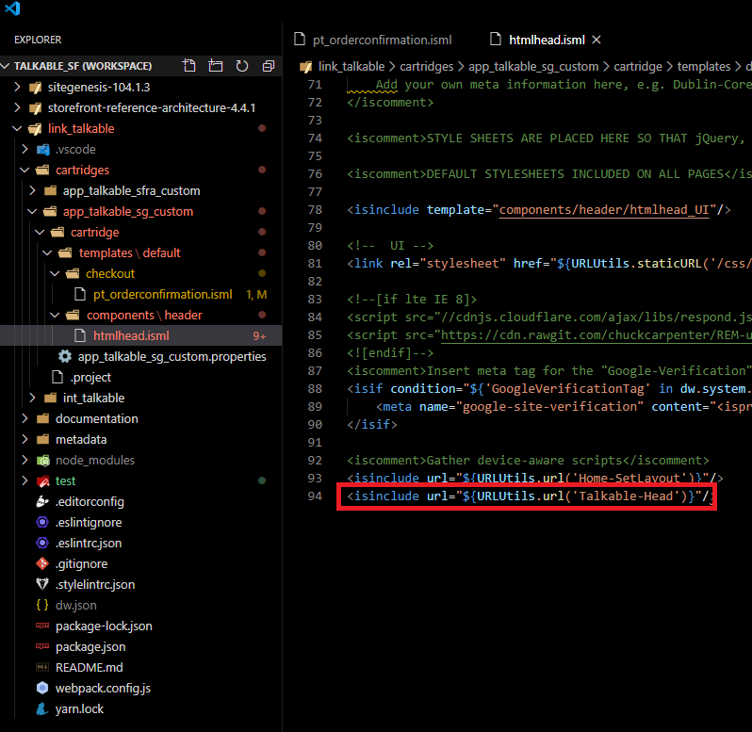

1. Copy “templates/default/checkout/pt_orderconfirmation.isml” file from app_storefront_core to your storefront customization cartridge following the same path and paste below code before the closing </body> tag:

<isinclude template=*"talkable/postCheckout"*/>

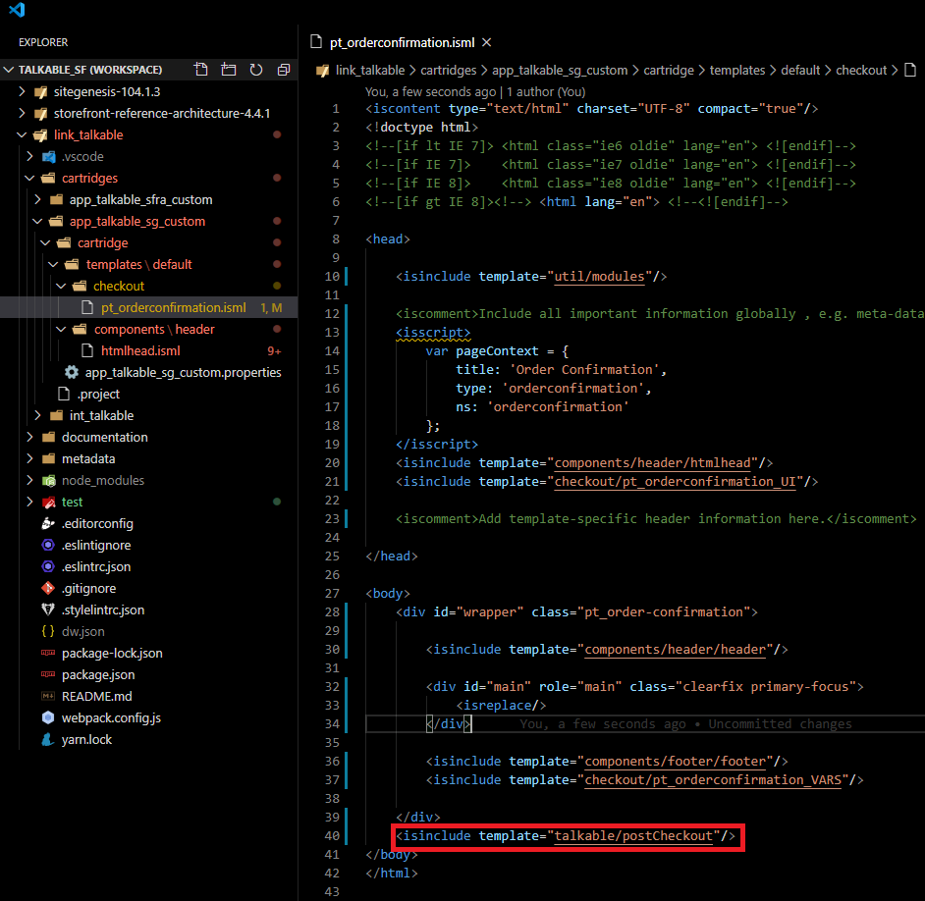

### SFRA customizations

* Controller change:

**Order.js**

In your storefront customization cartridge, extend *“Order”* controller’s *“Confirm”* method using the following code:

var server = require("server");

server.extend(module.superModule);

server.append("Confirm", function (req, res, next) {

    var OrderMgr = require("dw/order/OrderMgr");

    var viewData = res.getViewData();

    var talkableHelper = require("*/cartridge/scripts/talkable/libTalkable");

    var talkable = new talkableHelper.TalkableHelper();

    viewData.isPostCheckoutEnabled = talkable.isPostCheckoutEnabled();

    viewData.talkableSiteId = talkable.getSiteId();

    if (!empty(viewData.order)) {

        viewData.recentOrder = OrderMgr.getOrder(viewData.order.orderNumber);

        viewData.talkableData = talkable.getPurchaseData(viewData.recentOrder);

    }

    return next();

});

module.exports = server.exports();

* Template changes:

In your storefront customization cartridge, apply the following changes for the

following files.

**account/dashboardCard.isml**

Create the file “cartridge/templates/default/account/dashboardCard.isml” constructing the path if necessary by creating required folders and paste below code in it:

<div class="card">

    <div class="card-header clearfix">

        <h2 class="pull-left">${Resource.msg('label.referralDashboard','custom',null)}</h2>

        <a href="${URLUtils.url('Talkable-DashboardSfra')}" class="pull-right">${Resource.msg('link.view', 'account', null)}</a>

    </div>

</div>

**account/dashboardProfileCards.isml**

Create the file “cartridge/templates/default/account/dashboardProfileCards.isml” constructing the path if necessary by creating required folders and paste below code in it:

<div class="row justify-content-center">

    <div class="col-sm-6">

        <!---Profile--->

        <isinclude template="account/profileCard"/>

        <isif condition="${!pdict.account.isExternallyAuthenticated}">

            <!---Password--->

            <isinclude template="account/passwordCard"/>

        </isif>

        <!---Address Book--->

        <isinclude template="account/addressBookCard"/>

    </div>

    <div class="col-sm-6">

        <!---Order History--->

        <isif condition="${pdict.account.orderHistory}">

            <isset name="order" value="${pdict.account.orderHistory}" scope="page"/>

            <isinclude template="account/order/orderHistoryCard"/>

        </isif>

        <!---Payment--->

        <isinclude template="account/paymentCard"/>

        <isif condition="${require("*/cartridge/scripts/talkable/libTalkable").TalkableEnabled() === true}">

            <isinclude template="account/dashboardCard"/>

        </isif>

    </div>

</div>

**account/dashboardSfra.isml**

Create the file “cartridge/templates/default/account/dashboardSfra.isml” constructing the path if necessary by creating required folders and paste below code in it:

<iscontent type="text/html" charset="UTF-8" compact="true"/>

<isdecorate template="common/layout/page">

    <isscript>

        var assets = require('*/cartridge/scripts/assets.js');

        assets.addCss('/css/account/profile.css');

        assets.addJs('/js/profile.js');

    </isscript>

    <div class="container">

        <!---Breadcrumbs--->

        <isinclude template="components/breadcrumbs/pageBreadcrumbs"/>

        <div id="talkable-offer"></div>

        <div class="row">

            <div class="col text-center">

                <a href="${URLUtils.url('Account-Show')}" class="profile-back-to-account-link">${Resource.msg('link.profile.backtomyaccount','account',null)}</a>

            </div>

        </div>

    </div>

</isdecorate>

**checkout/confirmation/confirmation.isml**

Copy the file “cartridge/templates/default/checkout/confirmation/confirmation.isml” from app_storefront_base cartridge for SFRA storefront and add it to your customization cartridge constructing the path if necessary by creating required folders.

Paste the code below, right before the </isdecorate> closing tag:

<isif condition="${pdict.isPostCheckoutEnabled}">

<!-- Begin Talkable integration code -->

<isif condition="${empty(pdict.talkableSiteId)}">

    <!-- Talkable Site ID is blank, check your Talkable extension settings -->

<iselsif condition="${empty(pdict.recentOrder)}">

    <!-- Order could not be found -->

<iselse>

    <script type="text/javascript">

    _talkableq.push(["register_purchase", JSON.parse("<isprint value="${pdict.talkableData}" encoding="jsonvalue"/>")]);

    </script>

</isif>

<!-- End Talkable integration code -->

</isif>

**components/header/pageHeader.isml**

Copy the file “cartridge/templates/default/components/header/pageHeader.isml” from app_storefront_base cartridge for SFRA storefront and add it to your customization cartridge constructing the path if necessary, by creating required folders.

Paste the code below right before the </header> closing tag:

<isinclude url="${URLUtils.url('Talkable-Head')}"/>

**components/header/pageHeaderNomenu.isml**

Copy the file “cartridge/templates/default/components/header/pageHeaderNomenu.isml” from app_storefront_base cartridge for SFRA storefront and add it to your customization cartridge constructing the path if necessary, by creating required folders.

Paste the code below right before the </header> closing tag:

<isinclude url="${URLUtils.url('Talkable-Head')}"/>

**talkable/standaloneSfra.isml**

Create the file “cartridge/templates/default/talkable/standaloneSfra.isml” constructing the path if necessary by creating required folders and paste below code in it:

<iscontent type="text/html" charset="UTF-8" compact="true"/>

<isdecorate template="common/layout/page">

    <div id="talkable-offer"></div>

</isdecorate>

## External Interfaces

Talkable integrates with Salesforce Commerce Cloud Platform through JavaScript calls to Talkable API. All outside traffic from Salesforce Commerce Cloud instance is handled by HTTPS protocol.

Talkable integration documentation – <http://docs.talkable.com/integration/custom_integration.html>

## Firewall Requirements

Talkable does not need any special provisions in terms of firewall rule/open ports.

# Testing

For a complete list of test cases, please refer to the test cases document.

## Unit Tests

In order to run the unit test the following actions are needed:

* execute **yarn install** or **npm install** (if it was not already done)
* execute **yarn test** or **npm run test**

# Operations, Maintenance

## Data Storage

*Intentionally left blank.*

## Availability

The Talkable platform is expected to be available 24/7. However, if something should happen and Talkable does not respond, the user will not be able to see Talkable campaigns. During that time, the user will see a blank screen instead of Standalone and Advocate Dashboard campaigns. If there is a problem connecting to Talkable, the functionality and performance of your site will not degrade in any way.

## Failover/Recovery Process

In case of technical issue, please contact Talkable support

## Support

For technical support please contact your Talkable contact, or for cartridge specific questions you may email [support@talkable.com](mailto:support@talkable.com)

# User Guide

## Roles, Responsibilities

The store admin needs to follow setup instruction to add the Talkable cartridge, code, and configuration to make sure the integration will work properly. There are no recurring tasks that need to be fulfilled to set up the Talkable cartridge. As long as the configuration details are correct in your Site Preferences based on instructions in section 3.1, 3.2 and 3.3, then that is all that needs to be done.

## Business Manager

*Configuration options described above, in 3.2.*

## Storefront Functionality

### Storefront Invite Pop-Up

First step:



Second step: The customer has different options to share:



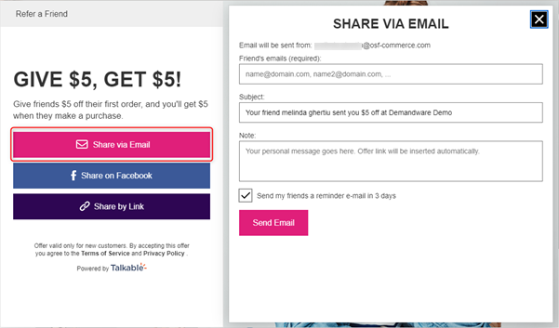

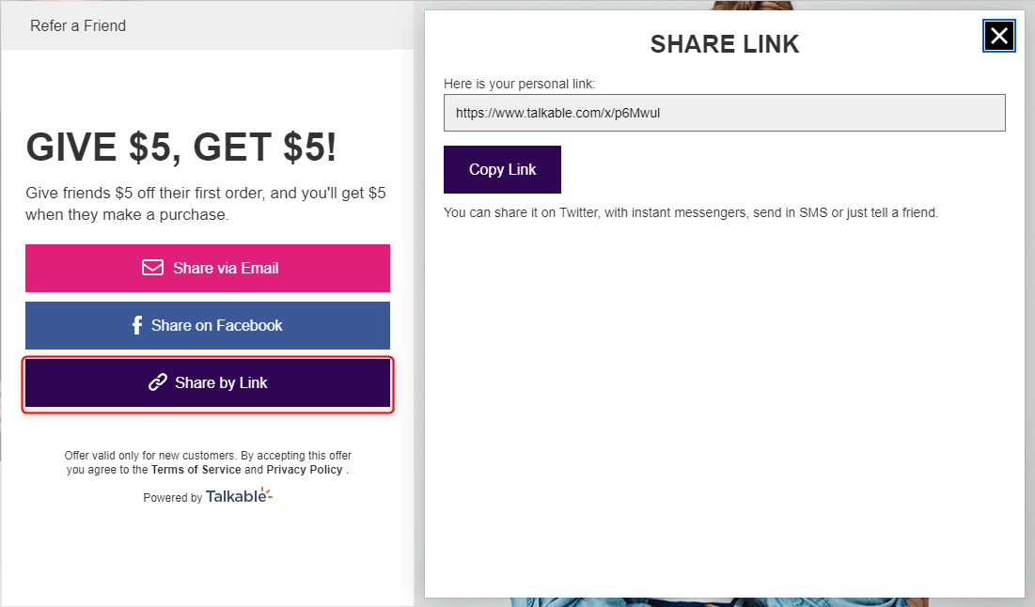

### Storefront Dashboard

The Storefront Dashboard provides Advocates a great insight on each of their shares as well as their associated rewards. Advocates are motivated to share more to achieve more rewards and can do that directly from their Dashboards.

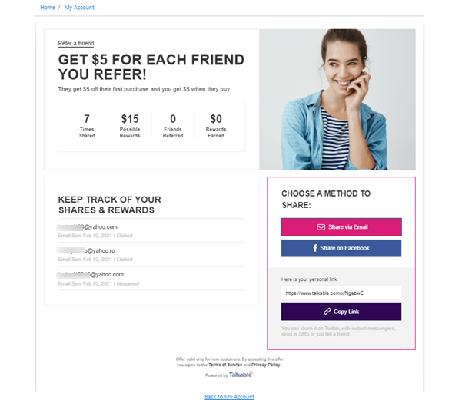  
*Storefront Dashboard.*

# Known Issues

*Intentionally left blank.*

# Release History

|  |  |  |
| --- | --- | --- |
| **Version** | **Date** | **Changes** |
| 17.1.0 | June 9, 2017 | Initial release |
| 18.1.0 | June 8, 2018 | Second release – Bug fixes and improvements |
| 20.1.0 | February 5, 2020 | Sfra compatibility, adaptable controller refactoring, ds to js conversion and best practices applications |
| 21.1.0 | February 5, 2021 | Updated integration to be compatible with latest storefront versions |
| 22.1.0 | February 10, 2022 | Updated integration to be compatible with latest storefront versions |